Cardiff Metropolitan University,
Cardiff School of Art & Design,
Bachelor of Arts (Honours)
Graphic Communication
Aidan Murphy

Capitalist Coercion: To What Extent Is the Border Between Propaganda and Branding Being Transgressed?

January 2021

Student Number – 20138647
Module Number - ADZ6999
Module Title - Constellation 3: Contribution
Module Leader – Sarah Smith
Dissertation Tutor – Theo Humphries

Capitalist Coercion: To What Extent Is the Border Between Propaganda and Branding Being Transgressed?
Aidan Murphy
Submitted for: BA (Hons) Graphic Communication
Cardiff Metropolitan University
Declaration:
“I declare that this dissertation has not already been accepted in substance, or in part, for any degree and is not currently submitted in candidature for any degree. I further affirm that the substance of this work is entirely the result of my own independent research, except where otherwise stated.”
Signed:
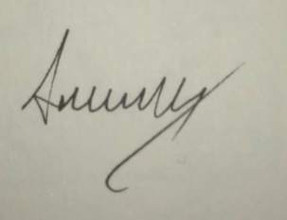
Full Name: Aidan Thomas Murphy
19th January 2021

Word count (including quotations): 10135
https://1850.home.blog/

Capitalist Coercion: To What Extent Is the Border Between Propaganda and Branding Being Transgressed?
Aidan Murphy
January 2021

“We’re all manipulators”
(Melissa Stringer)

Abstract
Propaganda is commonplace now, and always has been, however it is finding and has found its way into advertising but in an unknown amount. This may be due to its ability to affect those witnessing it without the knowledge of the consumer. Without being documented and researched the effects of propaganda in advertisements can run rampant and influence every decision any human ever makes. Within this dissertation both exposed and unexposed examples of propaganda in advertising will be analysed and researched for the purpose of attempting to begin the tracking of the border between propaganda and branding, analysing the events that influence the dynamic and shifting border of the two and exposing the techniques often used that allow propaganda to leak its way into the spheres of branding and perhaps even, without appropriate supervision, replace it entirely.

Contents
Introduction………………………..6
Chapter One………………………….7
Chapter Two…………………………12
Chapter Three……………………..20
Conclusion……………………….26
Image Reference List…………………………..28
Bibliography……………………..52

Introduction
The battle for people’s minds has been ever prevalent throughout history, there has never been a people without it. While it has always existed, has the creational pace of propaganda increased, in correlation with its secrecy? The modern propaganda machine has been perfected into a covert weapon used by not only many governments, but more recently, many manufacturers and retail companies. With the shift from explicit to implicit messaging methods, is it right that the general public should be influenced by these shadowy tactics, should companies be treating their customers as though they are unable to create their own impressions on the product that appears before them? Studying these advertisement methods will lead to a greater understanding and awareness of the unknown problems faced by multitudes of people. Propaganda existing within advertisement is an important topic to research given its ability to so heavily influence the events of the world and manipulate those who are victim to it, even without their knowledge that this is happening. This is especially dangerous in this specific context given that advertising and branding is conducted by household brands the entire public has put their trust into to make quality products and therefore, should adhere to guidelines. This research is hard found upon first reflection, and therefore makes this topic area an important one to highlight to prevent further unknown levels of transgression.
The study of propaganda is heavily researched and documented throughout history by many well-regarded authors and scholars. These research points must be considered and will assist in the formation of the outcomes achieved throughout. Given this is such a complex topic and issue, it is extremely important that all elements are accounted for and that not only the severity of propagandas transgression is brought up, but a select amount of necessary supplementary topics are brought up previously in order to ensure complete clarity by readers. And so, this Thesis has the purpose of educating as well as bringing attention to an issue that exists both contemporary, and historically.
Previous attempts at analysing this issue should be considered and form part of the end conclusion. These research points will need to be from varying timeframes and perhaps even nationalities in order to ensure clarity and fairness across the entire board of research. Assessing key examples within case studies assist in achieving a varied and evidentially backed up picture of the issue at hand as well as allowing the severity of the issue to be better appreciated and seen with greater urgency. Given that this issue concerns propagandas use of secrecy there will be elements that would create a stronger picture that will not be found within research due to both propagandas natural effectiveness while being hidden from public view, and the abundance of similar content which will take prevalence upon initial research.
The issue raised within this dissertation may need to be considered on a case-by-case basis, and so the case studies and examples chosen to have been chosen to assist in the creation of a general picture of the issue at hand, attempting to cover every base but also understanding and having an appreciation for the limitation that will occur, while it is vital that this issue be explored at length, it is equally vital to do this concisely as to assist in the translation of its urgency.
Finally, this dissertation appreciates the variance in the presence of propaganda-based advertising throughout varying industries, and so examples pulled out for further examination are to be taken as extreme examples that are used to highlight the most present and concerning within the word count frame available to it and within the topic area highlighted within the dissertation question itself.

Chapter One
What Is Branding?
In order to understanding complex and subtle changes in the behaviours of branding and advertising over time, one must first understand exactly what branding is and how to create it. By first listing the key characteristics of branding and advertising; Firstly, Name Brand Recognition is often used by larger companies whereby they will often throw their previous successful products into advertisements in order to convince audiences to trust newer products. A product branding ranges anywhere from the packaging of the product itself, to the logos and the advertisements, both physical and digital that potential customers may see around the world. While branding has existed for thousands of years, dating back to when farmers would brand their cattle (Fig. 1) for others to recognise that they are owned as well as who the owner is, the most common form of modern advertisement seen by the largest portion of the general public, as well as easiest to hide hidden messages within are T.V Ads. These ads can reach any member of the public, anywhere in the world, providing they watch any form of television or leave their house at any given point. Genuine advertisements will attempt to translate their products message in a neutral manner, simply displaying what the product is and how it can benefit the individual encountering the advertisement.
“this type of advertising relies on facts and figures to trigger a desired action; the ad’s message is usually framed in a compelling way. Informative advertising uses techniques that, instead of focusing on a clever way to convince customers to buy a product or service, chooses to rely solely on the strength of product features to encourage consumers to make purchases.” (Auburn Advertising, 2014)
Branding surrounds us in almost every object we encounter, “the average modern person is exposed to around 5,000 ads per day” (Clario, 2020). Whether it is something as obvious as a “Logo” displayed onto the project, or it is the unique shape in which the product is made that makes it recognisable as that company’s product e.g. Adidas Yeezy Boost trainers’ unique soles (Fig 2) or Grey Goose Vodka’s slender body and neck (Fig 3). These types of advertisements are often used by luxury brands that have customers who want people to know they have these expensive products, and so create outlandish looking products simply so they stand out from other products that currently exist. This is often known as “attitude branding” whereby the products are created to reflect the customers attitude and lifestyle/personality. The parallel to this is “No-Brand Branding” whereby the product is purposely left plain, suiting a minimalist and ambiguous style is created. The adverts of these companies generally reflect this style and Apple is perhaps the most famous example (Fig 4), although being parallels there is obvious crossover between these two advertising styles, by making something overly simple and minimalistic, the plain shapes may then be attributed to that company by default, this is extremely successful when customers begin to be reminded of certain products by seeing simple objects/shapes, Apple, again is an example of this. Gestalt plays a vital part in the creation of these associations, allowing designers “to create a more coherent design that will better connect with your audience.” (Creative Bloq, 2018)

Branding allows a product to translate certain traits of their product without the need for being actual conversation, “A picture is worth ten thousand words” (D.H Hepting 2013) certain colours like navy and purple translate a sense of royalty and luxury, the use of large serif/calligraphic fonts help to translate a similar kind of message (Fig 5). A brands reputation is built on the correct use of various techniques such as those previously mentioned and allows a rapport to be built with returning customers to that particular brand, however “Brand owners must constantly ensure that the qualities and values of their brands are maintained. They must continue to appeal to the consumer and should be developed in order to maintain their attractiveness in a changing society” (Hart, S & Murphy, J 1998). No brand will truly stand the test of time if it does not adapt and update its image overtime (Fig 6), trends will naturally bring certain brands into the spotlight for small periods of time however a “Power Brand”(Hart, S & Murphy, J 1998), these are the brands that have stood the test of time and have maintained the highest reputation among consumers around the world will slowly but consistently change their image to keep them up to date however will not change their image too fast for this to become too noticeable to the general public.
Branding is often such a powerful tool that the correct and appropriate use of it can often become a higher priority than the actual manufacture of the product itself. This often works for a certain amount of time, however there are famous examples of this being used incorrectly. An example of this is Jaguar cars and it is position it found itself in after a poorly managed manufacturing when unchecked. “in the 1970s when the product quality and reliability at Jaguar Cars plummeted. Sales followed the product quality spiral downwards, but when a new management restored quality, loyalty to the brand returned” (Fig 7) (Hart, S & Murphy, J 1998).
“consumers are not fools and will not maintain their support for a brand once it ceases to keep its side of the bargain” (Hart, S & Murphy, J 1998) This was almost half a century ago, the advancements in techniques and experience as well as brands being able to access users interests and trends easier than ever before the use of Brand Image over product quality is now potentially being used, yielding much more effective results for companies, with potentially disastrous effects for consumers all over the world.
What is Propaganda?
Pre 21st Century Propaganda
Propagandas true and unaltered definition is simply the spread of information in support of a cause, this is often surprising to the untrained eye that propaganda is not naturally sinister, it has instead been malformed and twisted due to its heavy involvement during wartime when propaganda is used to promote governments/individuals evil and unjust viewpoints unto the world (Fig 8). There is no word in the English language" "whose meaning has been so sadly distorted as the word for 'propaganda'” (Bernays, 1928). Older propaganda is mostly responsible for the word’s current reputation (Fig 9) due to older propagandas crystal clear visibility today, we can clearly see the fascist posters claiming a need for genocidal actions. Older propaganda often uses simpler forms of publication and psychological manipulation of viewers, simple colour theory clearly labels villains present within the posters and billboards that were often supported using an overwhelming amount of content assists to induce an altered psychological state within the ‘victim’. Examples of this were seen often in World War Two, when forces would air drops crates of propaganda instilling false messages within the public (Fig 10), sometimes being the more famously seen poster formats or simply false reports of wartime losses to indicate the public need to fear and ever advancing enemy is upon them.
While older propaganda messages are now highly transparent, the fabrication of false news reports was indeed a much easier process during the early 20th century due to a lack of publicly available technology, viewers of the propaganda techniques could not simply access the internet and see other people perspectives and video evidence. “One of the most popular shows in Britain during the time, Tommy Handley's It's That Man Again was able to reach up to 40% of the British population (Clario 2020). This, however, could also be utilised the in the opposite direction, if a country is perhaps experiencing heavy losses the truth could perhaps be covered up by printing false reports of victories and hiding away from any negative news, falsely instilling belief in a certain object/regime. This technique is perhaps more often seen than the former while a country is in peacetimes, sometimes used to settle internal debate within a high-tension nation. As peacetimes grow in duration the purpose of propaganda has ever shifted, assisted in the advancements in technology have perhaps created an invisible and dangerous weapon for companies to adopt within their very own advertising campaigns.
21st Century Propaganda
Newer, more modern forms of propaganda have taken advantage of the tools and circumstances available to them. The tools available now has allowed for blemish free photo manipulation and lightning-fast production as well as a worldwide far reach that does not require a large plane to literally “Drop” the leaflets to viewers. Modern propaganda falls into roughly seven separate categories that are used by companies in modern society. ‘Bandwagon’ Propaganda is like peer pressure, essentially using a product/company’s success to boast and invite new customers into buying the advertised product, e.g., 400 sold every minute or England’s Favourite Brand. (Fig 11) Piggybacking on previous success is an easy way to help guarantee sales, while avoiding displaying any actual debatable information about the product itself.

Card stacking is a form of propaganda that focuses on small positives while deliberately hiding the fact that negatives far outweigh the positives being displayed. (Fig 12) Examples are often seen within the food industry e.g., Fried chips containing 10% less fat while not mentioned the huge amount of health problems that occur due to the product, or the fact that they may be merely adjusting the portion size so that more fat can be contained within one portion. This leads to a product appear better and more beneficial than they are, this technique Is also prevalent within the involvement of hidden monetary charges. Thirdly is plain folks’ propaganda (Fig 13), an often seen but minimally impactful and very rarely noticed technique. Playing on the growing of distrust whereby companies will purposefully implant stereotypical “regular” looking people into advertisements to make a product appear more human, often seen within healthy eating companies and some lower cost bracket products that rely on making a more emotional connection in order to hold their customers to the advertised brand. In direct contrast to the previous technique, Testimonial propaganda (Fig 14) uses celebrity endorsements and appearances to instil trust by implanting a figure of authority and wealth into the appearance of the product. While these two are in direct contrast they are indeed all circumstantial and must be used at the correct times, for the correct type of products otherwise the adverse effect will be achieved, however also seen within the Testimonial technique are examples of having figures appear in dentist coats within toothpaste adverts, by placing a figure of authority it forces a message that the product is trustworthy, without the opportunity for debate from the viewer.

Storytelling Is often used to manipulate viewers emotions within propaganda, by manipulating a person emotionally the ability to cloud their judgment is achieved with much greater ease.” The hypodermic effect”. (Nahon-Serfaty, 2018), By using glittering generalities (Fig 15) small anecdotes translate often vague and emotional atmospheres that, in turn make the product being advertised far more appealing to buy without the need for much information about the product. This type of propaganda is often found in the form of lyrical phrases and metaphors. In addition to using emotionally manipulating anecdotes Propaganda utilising advertisements will also sometimes invoke name calling into the ads of their products (Fig 16) whereby they will deliberately compare their products to other competitors on the market, pointing out particular inferior traits and short comings, this is triply effective by not only boosting the status of their own product and by proxy, the buyers own confidence in themselves by purchasing that ‘superior’ product but also decrementing the competitors own image simultaneously, hurting their sales whilst boosting their own. Examples of this technique include a plant-based company would dislike the killing of animals and as such, would name call fast food chains who sell meat burgers killed in inhumane ways. Finally, a similar technique to this is Transfer Propaganda, (Fig 17) this is the technique of projecting certain qualities of a person or ideology, normally to demote one type of ingredient within a product forcing the public to trust them less, and buy e.g., less fizzy soft drinks, and then buy more natural fruit juices etc.

The tools of new propaganda have morphed more into the digital realm, using photoshop and photography editing to manipulate the product that is being advertised, and in some cases, in modern society, the possibility for the advertisement of a product/service that does not even exist. This combined with new digital forms of monetary balance have allowed companies to be funded by the success of a product before it is created/released. Recently an alternative to the Queens speech has been released, containing a deep fake, a concerning tool for those exposed to the effects of propaganda, the ability to create entire, undetectable alternatives showcase the sophisticated ability to make a convincing translation of almost anything, including events, products and certainly celebrity appearances, bending brand images to the creators will in any way imaginable.
Further examples of more techniques can be found here.
https://www.physics.smu.edu/pseudo/Propaganda/alldevices.html
https://www.youtube.com/watch?v=iOIoU9U9gZg

Chapter Two
Differences & Similarities
Differences
While the difference between propaganda and branding may, at first seem like the comparison of good and evil to the untrained eye, with the assistance of chapter one a more blurred line may begin to be discovered, propagandas dictionary definition is a clear example that in its truest form, it is not inherently evil, in comparison branding is not therefore inherently good. The Nazi war machine used a combination of the two techniques. Nazi ‘Marques’ are still recognised to this day, despite their previous, more innocent meaning within human history (Fig 18). If Nazi advertisements were to be converted into a company, their Marques and ideals shattering remembrance almost 100 years onwards would almost be something to be admired by some products and brands that failed to reach their century anniversary, given the swastikas memorable “modern” meaning it “surely ranks as one of the most successful brand logos ever designed” (Sky History, 2018). Given that branding can be used to symbolise these incredibly negative events, branding as a concept cannot be a wholly positive technique, whether its use is innocent or evil almost entirely depends on what it is being used for. As a contrast, propaganda can therefore be used positively (Fig 19) Such as within charity campaigns, using emotional and persuasive techniques in order to boost donations. Although the existence of its overtly negative image, its previously mentioned definition can be used to emotionally persuade groups to believe in a cause that means well. (Fig 20) This is a far more delicate and complicated technique, manipulating people’s emotions is perhaps rarely positive, it does overall “help transform our world into a society where it is harder for people to start thinking individually. Propaganda can influence control over what people believe, what people buy and how people live their lives.” (Bernays, 1928). Therefore, Propagandas definition is not entirely negative, however it is so easily used to hinder society due to the use of the practice of Propaganda and its lack of presentation of information and its reliance on somewhat blindly manipulating humans’ emotions it is perhaps beneficial for society if it were contained.
Propaganda is like the ugly twin of branding; it uses the same skill and visual elements to lure individuals and groups in with a false. Often mixing the truth with a lie in order to lure those in and take a perspective that already exists and encourage the perspective shared with the creator of the visuals and text. (Govloop, 2015)
In contrast, branding does not attempt to manipulate emotions without the presence of facts and will therefore push the same information to all its viewers, whereas propaganda may hide certain elements of the product/service. Branding uses a wholly informative base to create content. This allows the free exploration of the viewer to formulate their own opinion about the piece of branding presented before them. This in turn, creates a variation in outlooks by evicting heavy use of emotional manipulation, largely regulates and controls the responses to viewing the advertisement.
“The brand creates and generates a unique dialogue that did not previously exist, made through the empowering imagery and vivid colours combined together by the designers that make the brand.” (Hart, S & Murphy, J 1998)
In contrast with Branding creating a universal image for every platform of consumers/viewers, Propaganda is often seen within a “message per stakeholder” (Cambridge Dictionary, NDG) format, where only information that is deemed essential is portrayed to each section of consumers, giving creators of propaganda utilising material the ability to purposefully withhold information from others that would potentially expose a more sinister and harmful message/product. By withholding information there is more room for a product to have purely emotional impact, “propaganda can effectively manipulate emotions and cause durable changes”(Mattingly, Daniel and Yao, Elaine, 2020)) given that Propaganda works on an emotional basis and branding on an informative basis, less of one generally translates to a greater amount of the other, so therefore a company that will hide information about a product from certain groups of people will likely be doing so in order to input a greater amount of emotional based information.
This use of emotional, propaganda utilising advertising is present in all modern industries, and perhaps in larger companies that first thought it is not a tool used by the stricken off and hated brands but instead the use of emotional manipulation has bolstered their public image so much that they are considered luxury brands and have the higher bracket prices to reflect that, despite using similar or the same materials and production techniques as some of the markets cheapest. Fast Fashion is an industry heavily inundated with this phenomenon. (Fig 21)
“Fast fashion focuses on speed and low costs in order to deliver frequent new collections inspired by catwalk looks or celebrity styles. But it is particularly bad for the environment, as pressure to reduce cost and the time it takes to get a product from design to shop floor means that environmental corners are more likely to be cut. Criticisms of fast fashion include its negative environmental impact, water pollution, the use of toxic chemicals and increasing levels of textile waste” (Perry, P 2018)
Whether by lack of knowledge or consideration by the public, companies such as Zara and H&M have achieved a reputation of being trendy and responsible. Despite this, the fast fashion industry is the second largest polluter in the world, only falling below the oil industry, statistics include the production of polyester textiles alone emitting about 706 million tons of greenhouse gases a year, and hundreds of gallons of water go into making a cotton garment. Their ability to produce fashion lines instantly and cheaply makes for a consumer base that largely overlooks the negatives of Fast Fashion in turn for constant and cheap up to date clothes for all. (Fig 22, 23 & 24)
As well as mainly operating on an emotional basis, propaganda will also often lack A “Brand Purpose”. (Fig 25) For clarity, a brand purpose can easily be explained as a brands reason for existing beyond the purpose of generating revenue, this is similar and not to be confused with a Brands promise, something that is often mentioned within public advertisements a brands promise will often label vague and intangible elements such as “Delivering a great service every time” and “Selling quality and reliability”, whereas a brand purpose will benefit society. A brand purpose example would be Crayola and the encouraging of children to be creative as well as enabling their parents to help achieve that. “A powerful brand purpose can set a company apart from the crowd” (Don’t Panic 2019)

A brand purpose will help to achieve an emotional connection with your customers, although on the surface sounding like the previously mentioned subtle emotional manipulation of propaganda it Is in fact vastly different due to many factors; firstly, a brand purpose will only form one small part of an entire brands message and relationship with the consumer, whereas propaganda will potentially function completely on its own or form most of a brands message to consumers. A branding model will only function correctly if all five pillars of a brand model are engaged appropriately and in unison, the Five pillars of a brand model are as such.
- Honest – you have integrity; you are authentic; you do not lie, cheat or steal under the umbrella of the brand.
- Helpful – you do something that makes people’s lives better.
- Holy – you have a spiritual aim in mind, your intentions are morally upright, you’re not selling things that drag us down into the pit.
- Holistic – you think about all the ways people interact with the brand and you account for them. Including leadership – it works from the top down.
- Happy – ultimately you bring joy to people’s lives. (Govloop, 2015)

The lack of additional pillars within propaganda forces the consumer to form one viewpoint on the product and does not introduce a new and open dialogue from which the consumer is free to form their own opinion. Branding leaves itself open to some dislike, “your purpose won’t resonate with all buyers, it should appeal to your key demographic” (Don’t Panic, 2019). By branding being able to be disliked purely from its presented information it often means that the advertisement is presenting all aspects of the product before you, by presenting both the positive and negative points of its own product you, the consumer are then free to form your own opinion, without manipulation clouding one’s judgment.
Similarities
Branding and Propaganda exist in proximity and while differences can be easy to point out, they do share some factors that can also be noted. An important point to note is both branding, and propaganda aim to persuade the public to act. Many of the persuasion methods used in propaganda and advertising campaigns are the same. Knowledge of advertising principles and consumer behaviour is essential to an effective propaganda campaign even if no consumer product or service is being sold. In addition to this both Advertising and propaganda are found across multiple media platforms, they both can exist in practically every element of life. The disproportionate amount of similarities and differences is an important point to raise, the pure lack of evidence that these two techniques exist in complete similarity upon extended research combined with the initial perception that they do in fact go hand in hand raises concerns and the evidence suggests that these two pillars are not the same, but instead simply share a relationship that will wax and wane depending on the time period and political climate which they are examined within. Evidence supporting the dynamic and fluid relationship of propaganda can be examined in a contemporary situation by looking into the effects of COVID-19 across the world. (See: War on the Rocks, 2020)
Case Study
Identified as a fast fashion brand, Nike’s spending budget is listed, an increase is noticed. (Fig 26) Given previously analysed information within both branding and propaganda shows a clear space for transgression. Given fast fashions negative effects and irresponsible tendencies, yet Nikes well established and highly regarded status as the most popular sportswear brand in the world makes it strange that it remains a contributor to the second largest polluting industry on the planet, (The World Bank, 2019) this is not information often considered when a consumer thinks about Nike and its attributes. It’s ever rising budget for advertising is an example shown by many (Fig 27). “On average, Coca-Cola has spent an average of $4bn in advertising over the last six years. In 2018, the company spent $4.11bn on advertising, an increase of 3.6% from the $3.96bn spent in 2017. In 2016 the company spent $4bn on global advertising” (Business Insider 2020).
The lack of direct, accessible research for the creational pace of propaganda is a cause of concern for this topic. Only being able to translate the amount of propaganda being created by household brands by alluding to a larger than usual spending budgets is a statement to the covert and shadowy nature of propaganda itself. As well as a call to its constant and heavy existence within almost every brand we commonly know of. It would be advantageous to include academically backed up sources to support the statements made here, however the lack of evidence itself is the concern, and as such, evidence can therefore not be given.
Whose Responsibility is it?
(Cambridge Dictionary, DNG)
The complicated balancing act of encouraging and motivating companies and designers to create and sell their product to the very best of their abilities while attempting to filter out and prevent fraud from those that engage in propaganda riddled advertising is an issue that has plagued mankind since the beginning of time itself. But it is important to note who within the advertising and creation process holds the responsibility of ensuring that the branding does not cross too far into propaganda? The description of propaganda ensures that certain parties have information withheld from them, this is true for the audience, but it also occurs within the designers and creation teams themselves, the “need to know basis” spreads across the entire brand process, before, after and during exposing content to the audience.
With the need-to-know thresholds being different for each project, company and product. The issue must be looked at case by case to slowly build an overall picture. Fyre Festival is an infamous and contemporary event that falls directly within the category mentioned (Figure 28 & 29). Firstly, looking at the designers and the teams responsible for the creation of Fyre Festivals branding, “Oren Aks” was the lead designer (Fig 30) for the branding of Fyre Festival, Ak’s information, according to him was minimal in terms of what to make, why it was being made, and where it was going. “From the start, the brief wasn’t really a brief. It was just: This is our audience, this is what we’re trying to sell them,”. Aks clear lack of information and insight into the project points the blame away from the designer in this instance at first glance. But further study may suggest different, while he was not given sufficient insight to know the full extent of the errors made surrounding Fyre Festival, Aks and his team were responsible for the creation of the “crowning achievement” (Shwab, 2019) of Fyre Festival, the moment that created most influential members, and thus, the general public swiftly followed. “it was the idea to pay dozens of influencers to post a solid orange square on Instagram at the same time as a way of announcing the festival.” (Shwab, 2019)
Aks and his team admit to “effectively conjure emotions–feelings of fear of missing out” (Shwab, 2019). So, the evidence suggests that regardless of if Aks knew enough about the ill-natured intentions of Fyre festival, the designer, in this instance contributed greatly to the creation of an overarching propaganda influenced campaign. Interestingly Aks has his own opinion on the branding situation he found himself in and of the situation currently being discussed. Aks’ belief is one of “what people see is up to them”. An opinion that the buck stops with the general public, that consumers themselves must create their own boundaries on what is allowed and what is not. Companies should not be regulating their content and combing for emotional manipulation and that it is the audience that should feel they must act or behave differently after being intelligently and subtly emotionally manipulated by trusted, multinational or local companies.
The evidence suggests that, in this case the responsibility lies higher up. “I had no idea what my boss was up to, what the financial situation between him and our client looked like.” The source clearly suggests that Aks himself was unaware of the situation around him and points the responsibility towards those in charge of the third-party design organisation “JerryMedia”. However, given the designer himself suggests that the responsibility should lie with the public, where others would blame the creator himself. suggesting that responsibility will shift and alter case by case, and that human opinion plays an ultimate factor, something traditionally difficult to govern and punish/praise in response to.
Branding the Immaterial
With the support of previously mentioned descriptions of propaganda, perhaps nothing shows the existence of propaganda within branding Fyre Festival.
“In April 2017, roughly 5,000 people spent hundreds to thousands of dollars for tickets to what they thought would be the experience of a lifetime: a luxury music festival in an idyllic tropical setting on a private island in the Bahamas.” (CNBC Make it, 2019)
The festival contained hurricane disaster levels of accommodation with basic food rations and a severe lack of water. After the event, key organisers were punished, however the organisation and set up of the festival brought in millions of dollars of revenue. Until the very moment of guests arriving to the venue, the promises and propaganda held perceptions of an idyllic and unearthly experience. These propaganda tactics fooled not only high paying general public members, but also the acts themselves with “rappers Pusha T, Tyga, and Migos, as well as the band Blink-182 — dropped out in the days leading up to the event” (CNBC Make it, 2019). The ability to brand the immaterial is heavily reliant, but not entirely on the existence of social media and other digital platforms separating what is happening with the desired perceptions, having everything pass through a filter, with only the fine gold standard, out of context examples placed on the company’s advertising.
Using Fyre Festival as an example requires a certain amount of consideration for other factors as well as the heavy use of propaganda to advertise non-existent events. Firstly, more than propaganda was used to manipulate audiences and investors, lies about revenue and other factors were broadcasted to allow for greater involvement from investors, however, for the consumers themselves this was not a factor. Guests were paying “Up to $100,000 each” (BBC News, 2019). For packages and luxuries with renowned celebrities, who themselves were mistaken by the manipulative advertising as mentioned previously (Fig 31). Fyre festival is an effective example of advertising the immaterial within the 21st century, however it does not stand alone. The entire basis of crowdfunding and investments are based on successful ideas, not on the products as they are yet to be created. Given that “It’s getting harder and harder for people to discern what is real and what is not” (Fast Company, 2019). Due to advancements in technology, rising advertisement budgets, resulting in the transgression of propaganda into the realms of advertising and branding.
Pushing the timeline as far back as humans first attempts at creating and selling their wares and products, looking all the way back to discovered neo-lithic axes. Grimes Graves (Fig 32) is one of very few discovered neo-lithic flint mines, it is existence as a deep mine is evidence that even thousands of years ago humans were seeking aesthetic materials for a higher trade price, as evidenced here.
“One fundamental question relating to flint mining is why the Neolithic miners dug for flint when adequate surface deposits were available.” (English Heritage, NDG).
“in the quality of the underground flint. There are three bands - topstone, wallstone and floorstone. Floorstone is the finest and was reached by digging narrow, low, horizontal tunnels that radiate out from the bottom of the shafts. This flint is black, shiny and flawless looking much like the volcanic glass of obsidian.” (Megalithic, 2017).
Two distinct grades of tools can be found “crucially are divided into 'prestige' and 'normal artefacts” (Theater, AM 2008). A common theme can be found. (Fig 33) With declining quality of the blade of the axe itself, the actual functionality of the tools. The decorative elements can then be seen dramatically rising. With the highest quality axes having no decoration, implying the pure quality of the production would sell the axes themselves, whereas the less functional and poorer performing axes contain larger amounts of decoration. Likely to help distract from the lack of material functionality. “certain artefacts afford more power than others within a society through their ability to be exchanged”. Like Fyre Festival, where the lack of material production on the festival site itself was covered up by the hard hitting and emotional manipulative advertising strategies. These two examples are separated by thousands of years, but by peering into their core ideas, they are disastrously similar. This evidence suggests that while propagandas transgression is being supported by the advancements in technology, propaganda has, perhaps always overlapped with advertising. For as long as there has been manufactured goods, there has been examples of some with lacking quality. Where there is a void of stimulating and impressive ideas, humans will naturally begin to find other ways to distract from the lack of; filling the void with stories and decorations, delving into creating emotional connections to attract an audience as opposed to presenting innovative and well-made products that engage audiences less emotional reactions but engaging the more logical parts of the human brain. (Barthes, R, 1991)
Propaganda is so successful due to the studying and exploiting of the human mind itself, as humans, we are not perfect and there are clear and achievable shortcuts to achieve a desired outcome by bypassing logical areas of the brain, and ‘simply’ accessing emotional responses. “The public is completely uninterested in knowing whether the contest is rigged or not, and rightly so; it abandons itself to the primary virtue of the spectacle,” (Barthes, R 1991). Although discussing wrestling the analogies to mythologies with propaganda are clear, the evidence suggests they exist in a similar space, with the lack of actual information propaganda will “no longer matters whether the passion is genuine or not. What the public wants is the image of passion, not passion itself.” (Barthes, R 1991) The idea that propaganda more adheres to what the public wants, as opposed to what they need is a key point to bring up. The ability to access the more emotional side of a person’s brain by getting them what they want removes a considerable amount of logic from the conversation and therefore, anything can be translated once a consumer has been sufficiently manipulated. This Is not a hidden technique and is even encouraged within advertising, talks have been given on this type of advertising and is famously used by Apple and evidence suggests that therefore their actual branding elements are able to be so minimalistic and bare. Yet their success is so large that it is almost inaccessible by the human mind. (Fig 34) See more at:

https://www.ted.com/talks/simon_sinek_how_great_leaders_inspire_action?language=en

Chapter Three: Influence & Speculative

Propaganda has found its way into mainstream advertising. Clear examples of this include even some of the most well-known wartime propaganda posters have been adopted by various services around the world or exploited by organisations or by people of influence (Fig 35 & 36). It seems almost contradictory that wartime propaganda has had its meaning so twisted and contorted as to be considered wholly negative. Yet individuals and organisations of influence all around the world will use these images (and presumably the messages behind them) and create successful advertising campaigns with them. As discussed previously, the harmful and manipulative messages contained within pre 21st century propaganda is now common knowledge, yet these exact images are being used to create branding campaigns, showing an almost silent transgression of propaganda as it slowly leaks into the sphere of advertising. Perhaps a reason for why this has occurred without much detection is propagandas reputation as existing within a political space and not stretching any further. (political prop in pictures) Upon the research of propaganda and branding, the results are filled with political propaganda and surface level information. The transgression of propaganda within the world of advertising does not exist on the surface and instead seems to use the overt presence of political propaganda and pre 21st century machines as a cloak from which to transgress under. This lack of information concerning the tracking of propagandas existence within advertising throughout recent years is a cause for concern and allows the transgression to continue almost unnoticed, or unconcerned about.
Rosie The Riveter & Beyonce
(Fig 37 & 38) With the mention of WW2 propaganda being used in contemporary advertisements, perhaps most recent and prevalent is Beyonce (among others) utilising the image and the connotations of “Rosie the Riveter”. Somewhat of an icon within the feminism movement, bringing the image into the 21st century, changing the model out for one known better by a younger generation. Pondering the meaning of the image and then discovering its presumably feminist origins. On the surface this is true however the original image itself does find itself in the realm of controversy, appearing as “whitewashed” (Bell, P, 2014) and claims that the image itself “is not a feminist icon” (Winson, R, 2014). Evidence points both ways, many influential and powerful sources pointed out the clear positive and feminist links and pointed them out with haste.
“This is AWESOME because, as we know, young girls bloody love Instagram. Hopefully as they scroll through bikini pics and artfully angled photos of cups of tea and green juice, they'll come across Beyoncé's photo and wonder who the heck she's dressed up as. Maybe they'll do a google search, and learn more about the history of feminism. Cool stuff.”
(Scott, E, 2014)
While there is clear positive modern uses for the previously world war two propaganda found within the evidence here, the origins of the advertisement does suggest a more sinister purpose.
“propaganda conveniently ignored the fact that women would have been expected to carry on with the housework once they got in, and then, after a war spent being paid nearly 50% less than their male colleagues, would be sacked. When we dress up as her, we’re dressing up as an airbrushed fib.” (Winson, R, 2014)
The evidence here points towards Rosie the Riveters original purpose being somewhat like Keep Calm and Carry-On (Fig 39) purpose, manipulating women to simply knuckle down and carry on, despite the unfair circumstances they found themselves in throughout this time period and henceforth. Additional evidence suggests that this example is not inherently bad, but instead needs updating to a more modern example, pointing out that “More than 60 years after Miller put his head-scarved wet dream on to paper, she’s still feminism’s most visible icon of a working woman.” (Winson, R, 2014) . It seems the evidence here suggests a mere update is needed, this would seem to remove the era of world war two and it’s negative connotations within propaganda, however the reason for the use of world war propaganda within 21st century advertising has already been discusses and thus, the lack of an updated icon may lie here, alongside the negative connotations that Keep Calm and Carry on conceals within itself, the mention to a previous era with an advertisement that was never used during the period that it appears to represent is clearly a dangerous tool used for the purpose of the transgression of propaganda, and should be something that is analysed further with greater academic support and may lead to a many of the household phrases and icons to be looked at in an entirely different light.
The use of blaming or covering an issue up by concerning the public with something well documented throughout human history (Fig 40). The psychological effects of propaganda are only particularly useful when the user is unaware of their own exploitation. A prime example of this in practice is during World War one when comparing the two vastly different propaganda campaigns of Germany and the United Kingdom, the more subtle efforts of ‘Wellington House’ (Fig 41) allowed “Commercial publishers were used to give the impression that works were produced independently of state direction. Books and pamphlets were published in huge numbers and circulated to lists of people identified as opinion makers sympathetic to Britain. The intention was that popular support for Britain would be built through local advocates rather than appearing to come from Britain directly” (British Library, 2014), whereas in comparison, the German propaganda machine during World War one “tended to lack subtlety” (British Library, 2014) and as a result found itself “giving the game away” (British Library, 2014) (Fig 42) overall, reducing the effectiveness of the propaganda produced and at times creating an opposite effect on the public. (British Library, 2014) The transgression of propaganda into advertising must be a silent and covert one, in this strange case an absence of research and studies conducted within the subject matter serve only to strengthen and compound the message needing to be communicated.
Once the game is given away, propaganda loses its edge as users reactions to their emotions begin to become doubted and second guessed by themselves. The emotional manipulative tricks used to lure people into trust work only to cause distrust within the very organisations/brands themselves.
“Keep Calm and Carry On” & “Blitz Spirit”
“Few images of the last decade are quite so riddled with ideology, and few ‘historical’ artefacts are so utterly false” (Hartherly, O, 2016)
(Fig 39) With the subject of earlier 20th century propaganda being used an exploited for 21st century gain. “It’s on posters, mugs, tea towels and in headlines” (Hartherly, O, 2016). Keep calm and carry on, an originally “minor English middle-class cult object”, has been transformed due to modern usage and exploitation into an international brand. Why does this slogan, founded in small usage from the blitz period now hold the meaning of grit and determination across the globe? “English phenomenon had gone completely and inescapably global” (Hartherly, O, 2016). With a greatly concentrated emphasis within the United Kingdom. Evidence points the origin of this phrase within modern use within the “mass-produced until 2008”. Directly responding from not the crisis of starvation and annihilation, but from the “credit crunch and the banking crash”. It seems, from the evidence present that keep calm and carry on, and this feeling of “blitz spirit” (Historic UK, NDG) is invoked to unite and engage emotions across the country, and even, the globe. Further evidence of this established “Blitz Spirit” (Historic UK, NDG) being invoked post world war two timelines back to 1979, utilised by governments and companies “When Thatcherites and Blairites spoke of “hard choices” and “muddling through”, they often evoked the memories of 1941. It served to legitimate regimes that constantly argued that, despite appearances to the contrary, resources were scarce and there wasn’t enough money to go around” (Hatherley, O 2016).
Evidence suggests that the use of the Keep calm and carry-on phrase as well as the material that comes with it fits perfectly within the description of propaganda. The most key element of propaganda needing to be brought up for this example is that propaganda will create emotional attachment, without the existence of products, materials or meaning. For clarity, even though Keep Calm and Carry on has served to unite nations in historical and contemporary hardships, the phrase itself “has never been accurately defined, then or now”. Without any concrete meaning, containing only mere suggestions of resilience, the phrase has invoked such strong emotions across massive, global audiences. During World War Two, the time of its original invention, it functioned to distract the public from the horrors of war, even where propaganda phrases did not function to help. “The public face of the “blitz spirit” concealed the awful reality of being bombed” (Overy, R, 2020). With the use of war propaganda in the mid-20th century now being a crystal-clear method of emotional manipulation. These materials, the phrase keep calm and carry on, has been found to be used commonly in times of adversity, even with the historical and contemporary purposes of such advertisements being outed and manipulative. It has been purposely covering up disastrous events elsewhere “they had this supposed fighting spirit because they had to, because they had no other choice, rather than because they wanted to carry on!”. (Fig 42) The phenomenon of blitz spirit, positivity in the face of constant bombing and a “grim willingness to carry on because they had no other choice” (Historic UK, NDG) appears to In fact be a fabricated one, others have researched into “blitz spirit” and the evidence suggests that it is false. (Historic UK, NDG).
Contrasting this evidence with the success of the use of campaigns like keep calm and carry on it must be discussed why this form of propaganda is so successful and so existent in view of the general public. The timeframe of the original production of keep calm and carry on is something needing to be noted foremost, mostly the interlinking with this concept of “Blitz Spirit” and the idea that this is “established narrative about Britain’s “finest hour”” (Hatherley, O, 2016). Subsequently the positive reactions seen from the use of keep calm and carry on within a 21st century timeline should then be seen in a more concentrated dosage among those who grew up/were of an easily influenced age during this period in history, the generation of “two world wars and one world cup” (USA Today, NDG). The harking back to the glorious youth but concentrating on one very focussed part of a generation, with careful image tending that has allowed keep calm and carry on being used “as a means of not thinking about other aspects of recent British history” (Hatherley, O, 2016).
And so, it must be that nostalgia plays a part in certain aspects of propaganda. The description fits well, by simply referencing back to a previous period, where much of the audience that will be receiving the information would not have experienced first-hand the events that are being referenced. “the memory invoked by the Keep Calm and Carry-On poster is not based on lived experience.” (Hatherley, O, 2016). However, in the example of keep calm and carry on, the call back to blitz spirit is a false one, perhaps in a similar manor to the meaning of propaganda itself, the apparent purpose behind keep calm and carry on has been contorted and concealed at appropriate times and seemingly given a fabricated meaning, this meaning now acts as a warrant for the phrases manipulative use within every 21st century crisis the world faces, from the credit crunch to the impact COVID-19 is currently inflicting on the world.
However, further evidence of transgressional propaganda within the keep calm and carry-on phrase can be found in its origin. “before 2008, few had ever seen the words “Keep Calm and Carry On” displayed in a public place.” (Hatherley, O, 2016). Its failure to exist in prominence during World War Two but the phrases close correlation with this phenomenon of “Blitz Spirit” shows clear contortion of the phrase, merely acting as a tool to command the public to react a certain way to a crisis. “it was one in a set of three”, an interesting piece of evidence which supports the position of manipulation being present can be found when the phrases alternatives that were produced and tested during world war two are explored in detail. Of the two alternative phrases, one is particularly worthy of mention and it goes:
“YOUR COURAGE
YOUR CHEERFULNESS
YOUR RESOLUTION
WILL BRING
US VICTORY” (Hatherley, O, 2016) (Fig 43)
Given that this phrase was released and shown “widely displayed during the blitz” (Hatherley, O, 2016) and contains similar structure and meaning to keep calm and carry on, it allows for the study of public opinion during the blitz itself. After short research evidence seems to suggest that it met with largely negative responses
“The other posters were heavily criticised. The social research project Mass Observation recorded many furious reactions to the patronising tone of YOUR COURAGE … and its implied distinction between YOU, the common person, and US, the state to be defended.” (Hatherley, O, 2016)
Evidence suggests that the public that were present during the blitz found these phrases patronising and disliked them immensely. The similar structure shared between the two phrases being examined would suggest that if keep calm and carry on were released into the general public during the blitz, it would be met with similarly negative responses. Further evidence supports this and gives explanations as to why it may not have been successful.
“We can be fairly sure that if KEEP CALM AND CARRY ON had been mass-produced, it would have infuriated those who were being implored to be calm. Wrenched out of this context and exhumed in the 21st century, however, the poster appears to flatter, rather than hector, the public it is aimed at.” (Hatherley, O, 2016). This evidence supports the idea that keep calm and carry on, despite being used to invoke “blitz spirit” in fact did not have the support of the public during the actual time period it is considered in circulation. Yet it continues to have a profound effect on the public when the phrase is utilised during times of crisis. The true meaning appears to be used to “normalise surveillance and security through an ironic, depoliticised aesthetic.” (Hatherley, O, 2016). Having this hidden, second meaning that is not known to the public allows this phrase to appear as advertisement. And due to the propagandic elements being hidden from public view it enables it to perform to the highest manipulative standards and has thus allowed the phrase to infiltrate homes and buildings all over the world, spreading a message that does not exist.
In conclusion, the keep calm and carry-on phrase is a prime example of the existence of propaganda within an advertising space. This is due to its hidden second meanings, deceitful origin as well as its general lack of concrete definition. Instead, it appears to allude to some previous generation that simply continued forwards, disregarding the events occurring around them. With the examination of the phrase, many of these factors can be found to be of fabrication, in order to allow for less innocent messages to be implemented.
Speculative and the Future
With the detection of propaganda in advertisements becoming ever more difficult to detect, this is unlikely to halt. While there has always been a closely linked relationship between advertising and propaganda and their relationships can be seen becoming closer with every crisis ravishing the world around us as well as the endless advancement in propaganda producing technology. Humans are currently utilising machines to aid in their creation of propaganda riddled advertisements, but evidence suggests that “The supply of disinformation will soon be infinite” (DiResta, R, 2020). This will likely be caused by humans soon ability to allow “quote about AI being able to create propaganda soon” (DiResta, R, 2020). With the existence of Moore’s law, “Moore's Law states that we can expect the speed and capability of our computers to increase every couple of years, and we will pay less for them. Another tenet of Moore's Law asserts that this growth is exponential. (Investopedia, 2020) . Technology is already able to create articles and advertisements, relatively unaided, to a basic, but detectable extent “robots have a long track-record of automating human labor. There are already algorithms that can write stories” (Lafrance, A, 2020) This will, however, likely introduce further advancement in propaganda detection technology. Thus, restoring the delicate and seemingly endless close knitted relationship between propaganda and advertising, likely allowing those who seek to create ill-natured advertisements to do so. But this is still at the risk of detection, like the phenomenon of Fyre Festival. A question to ask is, when will it be known that this is happening? Is it already occurring, and it simply utilises the natural cover yielded by focus on the more surface level political propaganda that floods search results and covers news headlines so that it may move without detection. And if it then can move without detection it must then; move with total efficiency.
Conclusion
In conclusion, propaganda and branding have existed for as long as records themselves. With this, their intertwining relationship has always been existent. Although, it has waxed and waned, unprotected from the events and crisis’ that occur throughout history, their relationship, when examined in one isolated timeframe can give a distorted picture of the true meanings and relationship of the two. Propaganda has been the victim of the most extensive distortion of meaning of a word, due to its uses in campaigns throughout the last 125 years. However, its reputation as a negative phrase is not entirely wrong, this issue seems to sit with the human mind itself, subtle emotional manipulation is not negative, but the minds it is manipulating are perhaps not well enough equipped to respond and deal with this manipulation. While propaganda is not wholly bad, branding is not wholly good, such is the nature of their relationship. The two mediums will exist in a tight or looser relationship depending on the current state of the world around them. Evidence suggests that, during times of crisis, propaganda and manipulation transgresses and leaks into the realm of branding, this is often during times of war (which seems where propagandas distortion of definition is most prevalent today). The similarities are outweighed by the difference between the two, however, this is only massively prevalent upon extensive research of this topic. Researching this is tainted with surface level political propaganda, making the more subtle existence of it within an advertising space just that much less detectable as well as making the examination of the phenomenon difficult.
It seems, that propaganda has always found its way into advertising, acting as a buffer to bolster less than optimum products. This is done through countless techniques that, if it were to be examined thoroughly enough, could be found in almost every advertisement in existence. However, given the constant changing, developing and morphing medias, aesthetics and themes of advertising it is constantly moving forwards. This makes the exposure of a previous generation’s propaganda clear to the eye, but the current generation seem more blind to the existence of the propaganda that is occurring around them. Therefore, meaning nostalgia plays an important part of propagandas transgression. Advertisements appear to appeal to the previous generation within a current time by simply referencing the propaganda that was in prevalence when they themselves were younger. These advertisements can often be found to not contain any meaning and will commonly exhibit the most extensive examples of propaganda transgression and therefore, make for prime case studies.
Propaganda appears to be effective in its transgression due to its common use and its popularity within advertising. It works so much more effectively than advertising due to its adhesion to what humans want, as opposed to what they need. Typically, grandiloquence plays a part in the effectiveness of propaganda as well as it is ability to make consumers disregard whether something is ill natured, rigged, or not.
From the research conducted propaganda appears more as a spectrum rather than a simple one-word phrase that is thrown around so commonly. Something is not either propaganda or branding, but instead takes aspects from both. How much of each is used and whether it is a disproportionate amount must be taken on a case-by-case basis. The responsibility of announcing when the advertisement stretches too far into propaganda appears to also be something that must be taken case by case. The person with who the buck stops at is a matter of varying opinion, the evidence suggests that due to this variance in answers, everyone along the production and consumption line must play a small part in the halting of the transgression of emotionally manipulative propaganda.
For as long as propaganda is not detected, its effectiveness and efficiency are its highest point. This makes the study of this topic a particularly challenging one alongside the other factors mentioned previously, especially when examining contemporary examples that may not have had their chance to be fully exposed for what they are at the time of examination.
Due to the development, propaganda has transgressed almost entirely into the realm of advertising and the two are closer than they have ever been before. There is sufficient evidence that says that propaganda is always found transgressing, as it adheres to a more basic animalistic and less sophisticated instinct, engaging the more emotional side of human brains. An emotional attachment that is often so desired by brands and advertisements, achieved so much easier with the assistance of propaganda. Given the examples of propaganda present within products date back to the beginning of human crafting itself it cannot be said with certainty that this is a new phenomenon. It seems that while contemporary examples show a clear close knitted relationship between the two, they have possibly always existed within each other, endlessly drawing influence and inspiration from one another, this will continue to do so when new propaganda production and detection tools have been developed, and thus, outdated again.
Image References/Figures

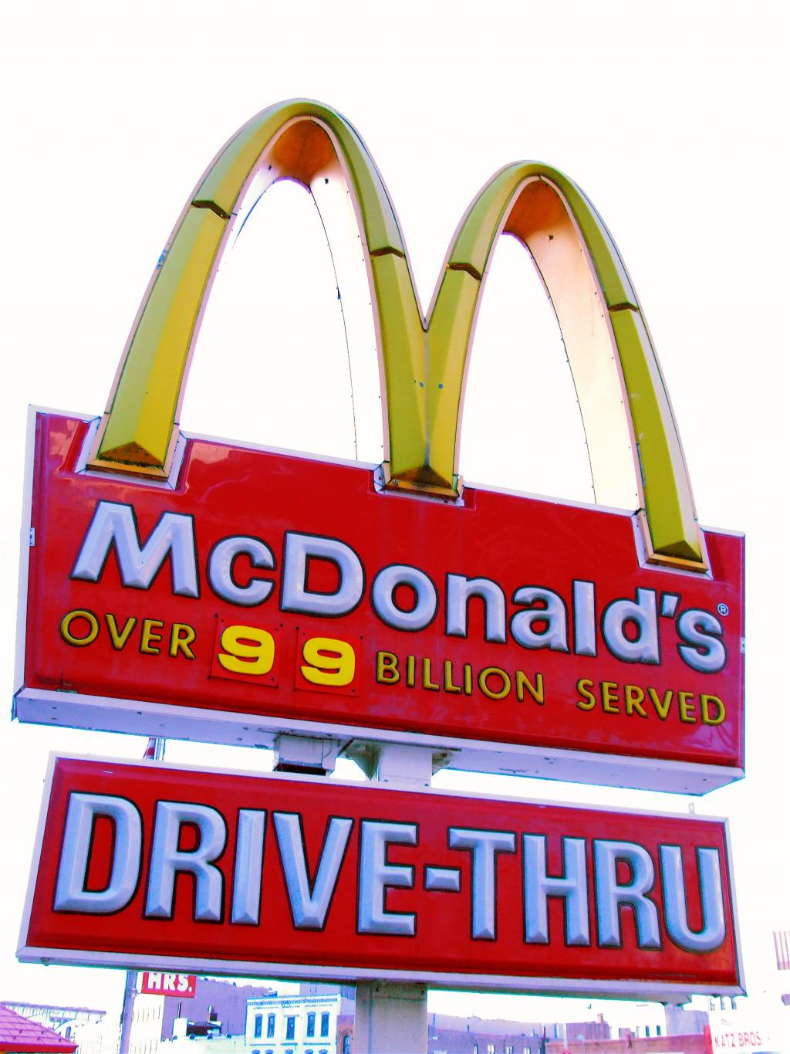
(Fig 11) Smith, S (2008), Mcdonalds’ sign in Harlem [Image Online] Available at: https://upload.wikimedia.org/wikipedia/commons/7/73/Harlem_Micky_Dz.jpg [Accessed 01/05/20]


(Fig. 1) Freeze brand of heifer #699 (2020), Freeze Branding Cattle, Available at: https://extension.sdstate.edu/freeze-branding-cattle [Accessed 04/05/20]
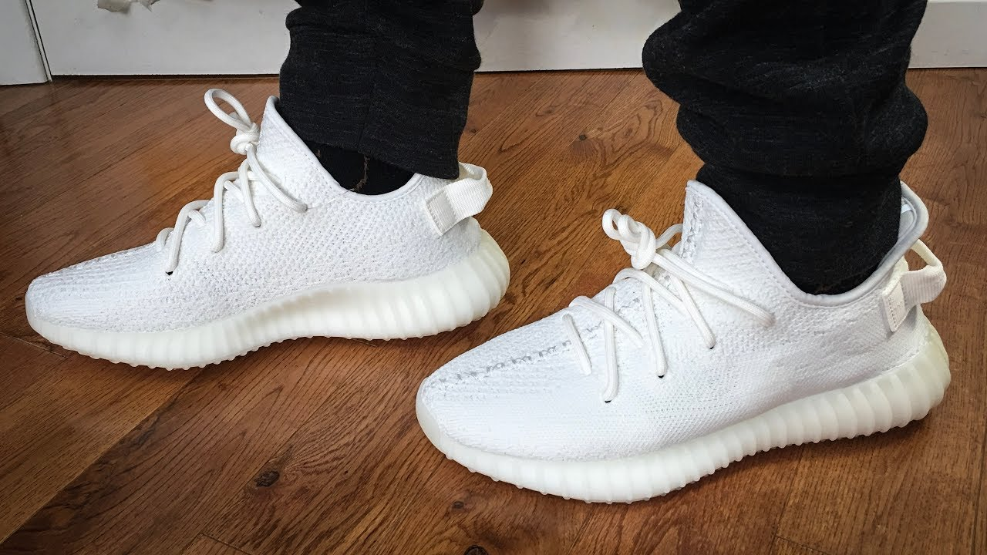
(Fig 2) Yeezy Cream Triple White (2018), gms-sklenak [Online] Available at : https://www.gms-sklenak.de/262-ubrukte-yeezy-boost-350-v2-2973.html [Accessed 05/05/20]
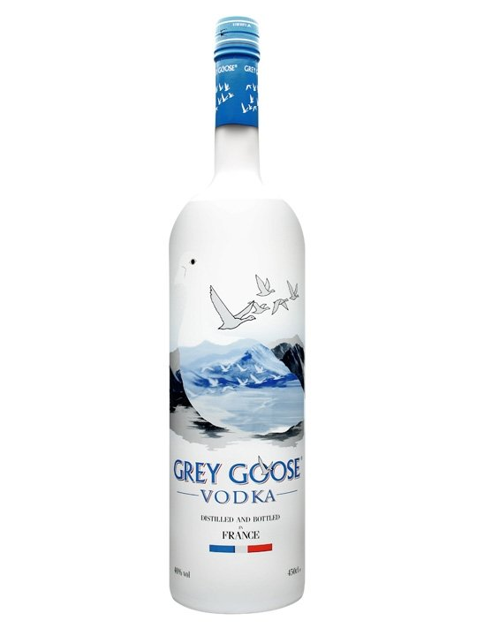
(Fig 3) GRAY GOOSE 3LT (NDG), Wineshop.gr [Online] Available at: https://www.wineshop.gr/grey-goose-3lt.html [Accessed 05/05/20]
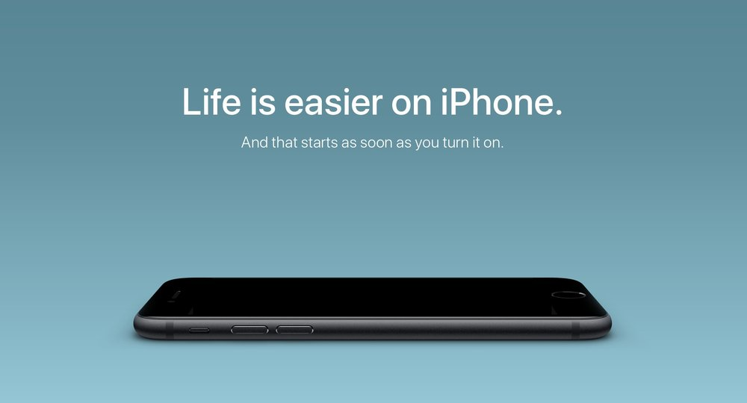
(Fig 4) Apple S Campaign (2018), The Power of Advertisement [Online] Available at: https://mdasid.org/ [Accessed 06/05/20]
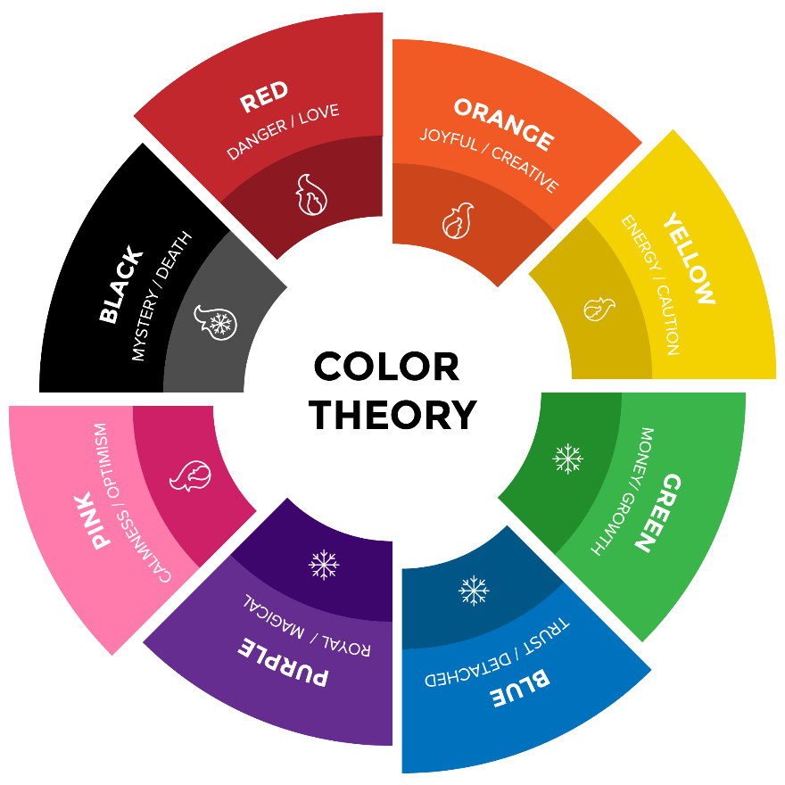
(Fig 5) The brand colour wheel (2019), The colour effect [Online] Available at: https://medium.com/@pushupincorporation/the-colour-effect-3c789e3e1fd4 [Accessed 07/05//20]
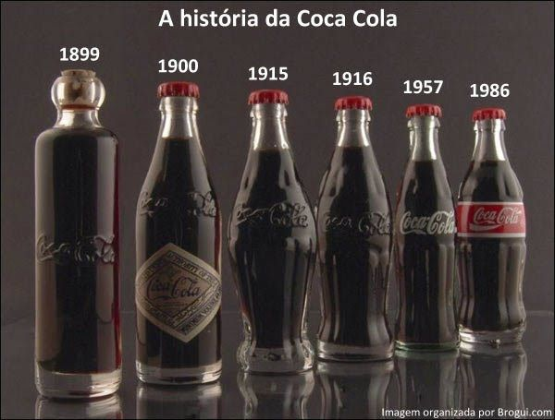
(Fig 6) Evolution of Coca-Cola (2011), 43 Historical photos [online] Available at: https://umapartedomundo.wordpress.com/2011/07/09/43-fotos-historicas/ [Accessed 08/05/20]
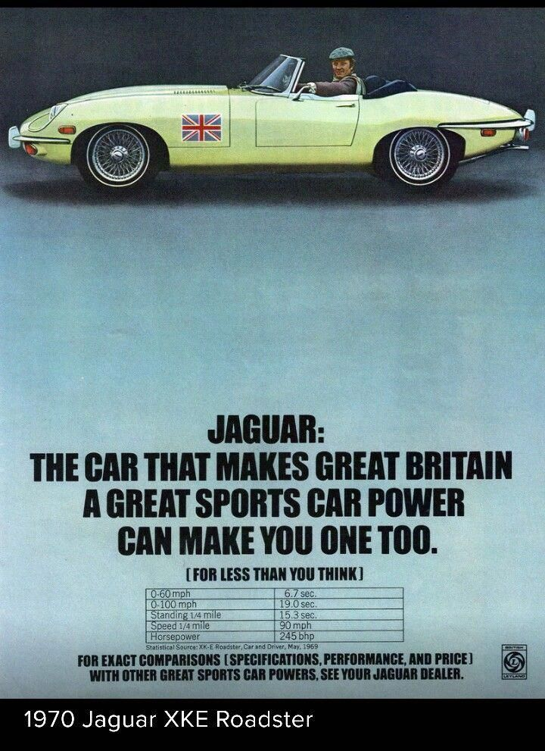
(Fig 7) Jaguar Xke Jaguarclassicscars (1970), 1969 Jaguar Xke Horsepower [Online] Available at: http://seputar-balapan.blogspot.com/1969/12/1969-jaguar-xke-horsepower.html [Accessed 09/05/20]
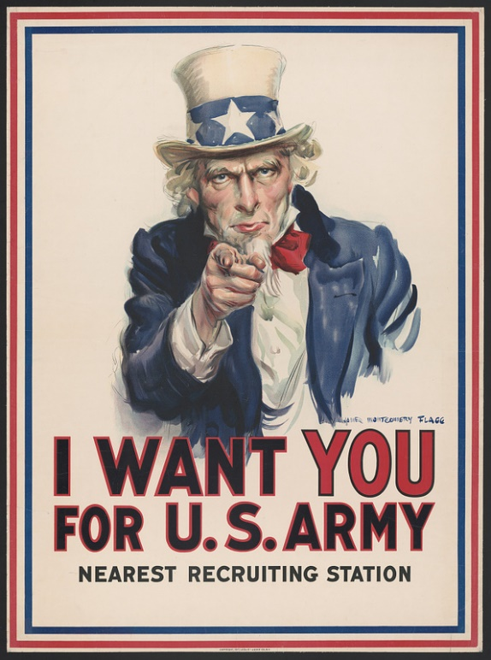
(Fig 8) Uncle Sam, (2020) Library of Congress [Online] Available at: https://medium.com/the-collector/i-want-you-to-reclaim-the-united-states-flag-in-the-name-of-liberty-and-justice-for-all-196b2e3a51e5 [Accessed 10/05/20]
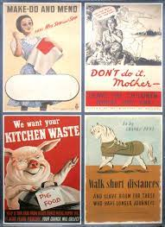
(Fig 9) Collection of Posters (NDG), Popflock [Online] Available at: http://www.popflock.com/learn?s=Careless_Talk_Costs_Lives_(propaganda) [Accessed 10/05/20]
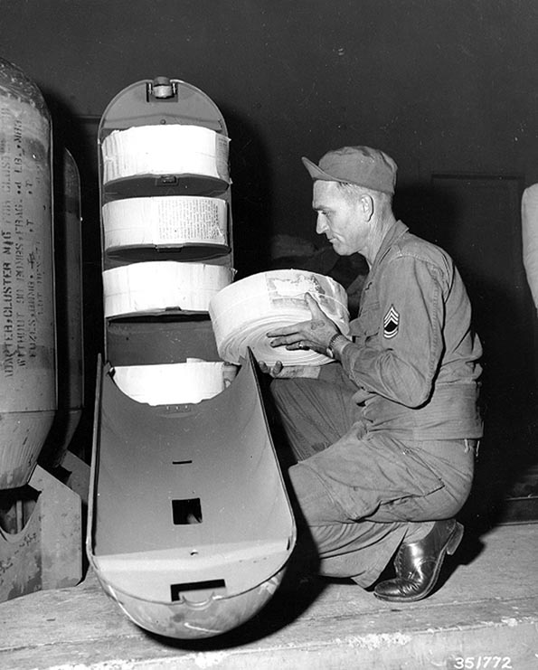
(Fig 10) M16M1 Cluster adapter (1950) FEC Printing Plant, Yokohama, Japan [Photograph] from the All Hand collection Naval History and Heritage Command Available at: https://www.history.navy.mil/content/history/nhhc/browse-by-topic/wars-conflicts-and-operations/korean-war/korea-imagery.html

(Fig 18) German Signs and Symbols Choice Image – Hindu Swastika (NDG), Jing.FM [Online] Available at: https://www.jing.fm/iclip/hRRmR_german-signs-and-symbols-choice-image-hindu-swastika/ [Accessed 12/06/20]

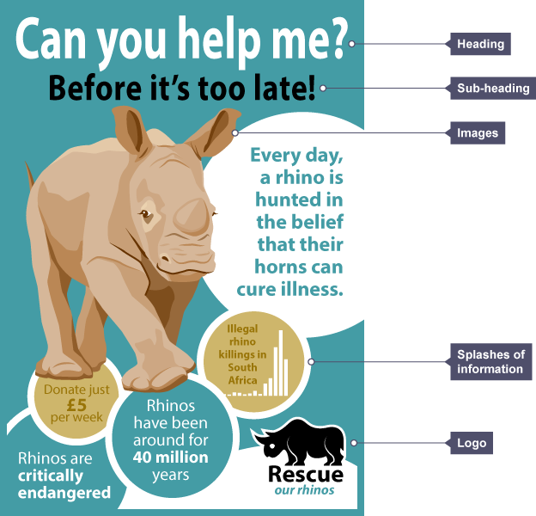
(Fig 19) Rhino Leaflet (NDG), Writing to Persuade [Online] Available at: https://www.bbc.co.uk/bitesize/articles/z6j8g7h [Accessed 10/05/20]

(Fig 20) Oral-B (NDG), Advertising Family Guide [Online] Available at: https://www.hhsi.us/wp-content/uploads/2020/06/Advertising-Online-Family.pdf [Accessed 15/05/20]

(Fig 21) H&M (2020), Designing and Social Media Management [Online] Available at: https://dubai.dubizzle.com/community/freelancers/2020/12/4/designing-and-social-media-management-2---8c4c1a3688524271b8fffcb6b3f80698/ [Accessed 17/05/20]
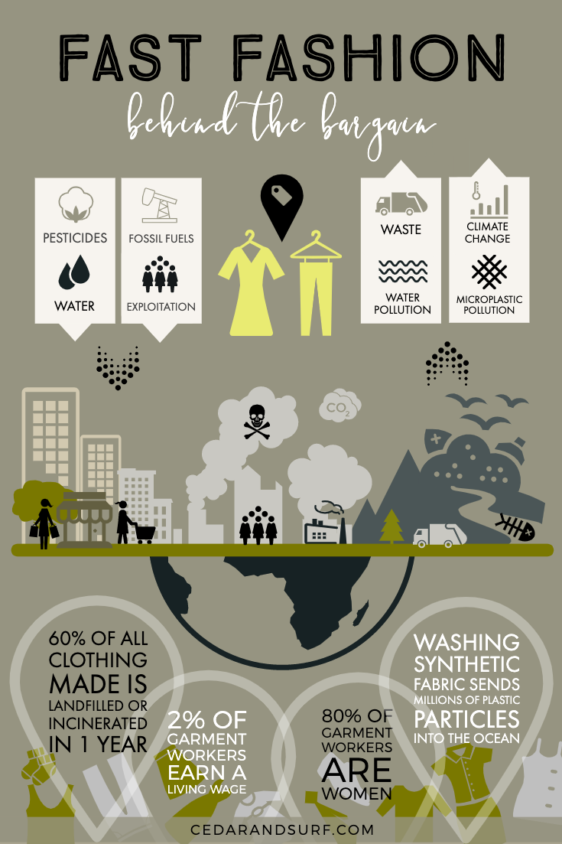
(Fig 22) Fast Fashion Infographic (2020), The Happy Blonde Blog [Online] Available at: https://thehappyblondeblog.home.blog/author/amanda477782b3e5/#jp-carousel-334 [Accessed 19/05/20]
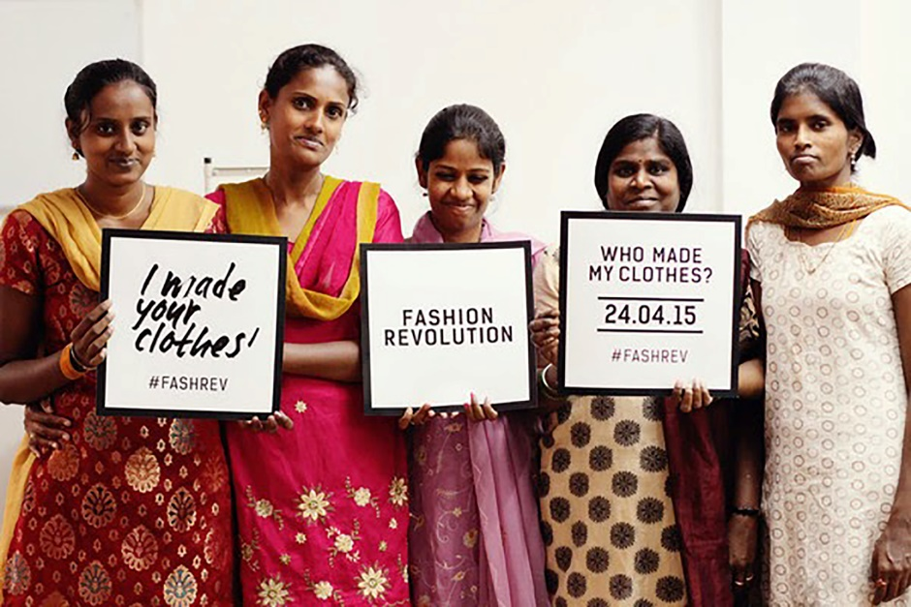
(Fig 23) Fashion Revolution (2016) Norbyah [Online] Available at: https://www.imanorbyah.com/2016/04/ [Accessed 20/05/20]
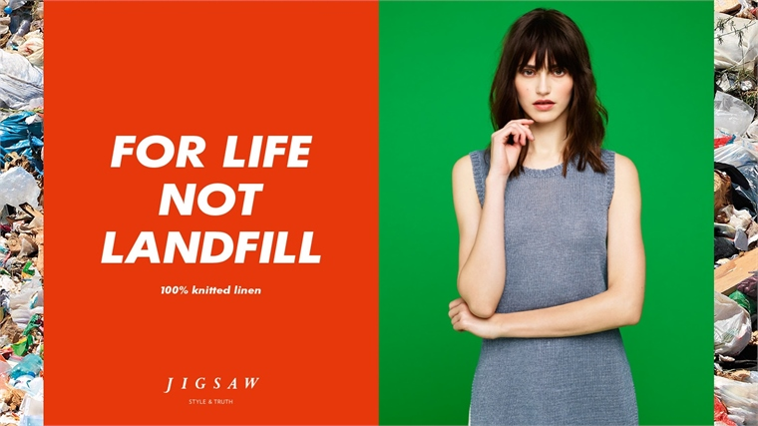
(Fig 24) Slow Fashion Ad (2015) A Space for Activism: Patagonia Flagship, NYC [Online] Available at: https://www.stylus.com/srqftw [Accessed at 22/05/20]
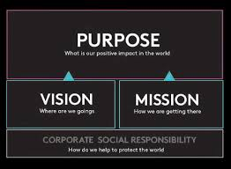
(Fig 25) Brand Purpose (2020) Company’s Purpose Is Not Its Vision [Online] Available at: http://annettesabode.com/companys-purpose-is-not-its-vision/ [Accessed 27/05/20]

(Fig 28) Fyre Branding (2019) Twitter Thread [Online] Available at: https://twitter.com/7shr/status/1120549232342183936/photo/1 [Accessed 01/06/20]
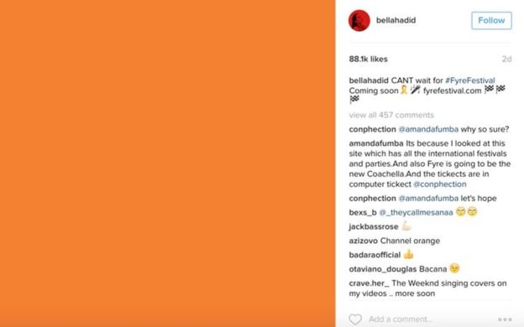
(Fig 29) Fyre Branding (2019) The Fyre Festival and the Trumpet of Amplification [Online] Available at: https://hapgood.us/2019/01/ [Accessed 01/06/20]

(Fig 30) Oren Aks (2019) TheFounderHour [Online] Available at: https://www.thefounderhour.com/episodes/oren-aks-atomic-milk-media-jerry-media-fyre-festival [Accessed 01/06/20]
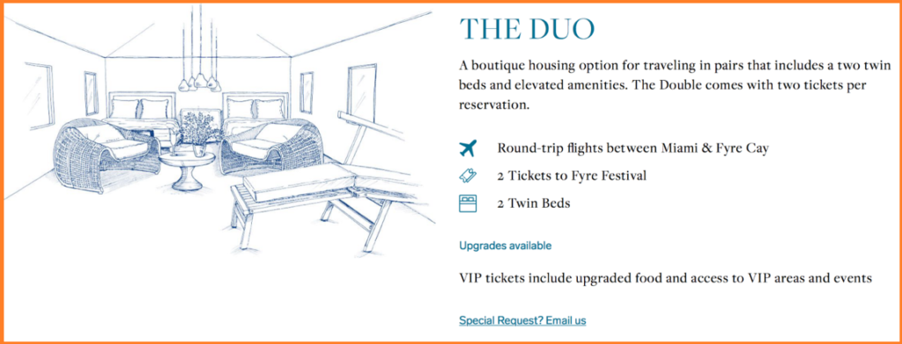
(Fig 31) Huber, S (2019) How the Fyre Festival was Branded [Online] Available at: https://magazine.keycaribe.com/events/move-over-fyre-festival-the-bahamas-has-so-much-more-to-offer/ [Accessed 01/06/20]
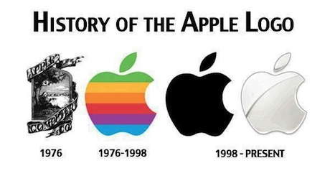
(Fig 34) Gutierrez. D (NDG) History of the Apple Logo [Online] Available at: https://diegosproject.weebly.com/# [Accessed 01/06/20]
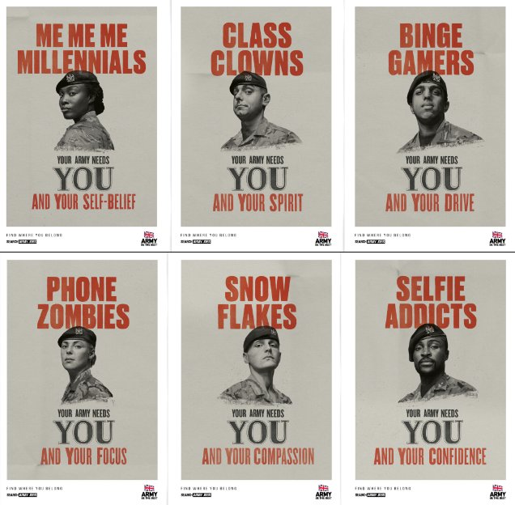
(Fig 35) UK Army (2018) Advertisingrow [Online] Available at: https://advertisingrow.com/advertising/creative/creative-advertising-snowflakes-me-me-me-millennials-phone-zombies-the-british-army-wants-you/ [Accessed 03/06/20]
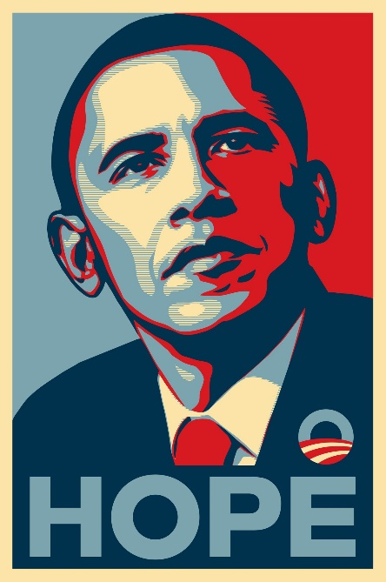
(Fig 36) Shepard Fairey (2008) Obama Hope Poster [Online] Available at: https://medium.com/fgd1-the-archive/obama-hope-poster-by-shepard-fairey-1307a8b6c7be [Accessed 04/06/20]
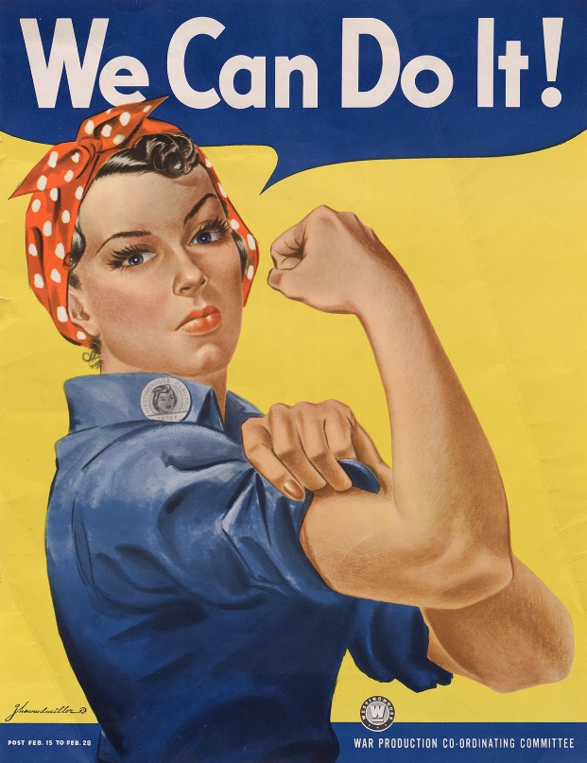
(Fig 37) Rosie the Riveter (1943) J.Howard Miller [Online] Available at: https://www.britannica.com/topic/Rosie-the-Riveter [Accessed at 10/10/20]
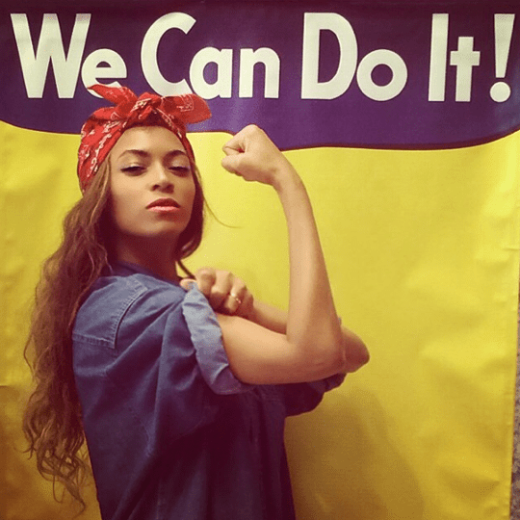
(Fig 38)Beyonce (2014) We Can Do It! [Online] Available at: https://www.instagram.com/p/qwWCsgPw7N/ [Accessed 12/12/20]
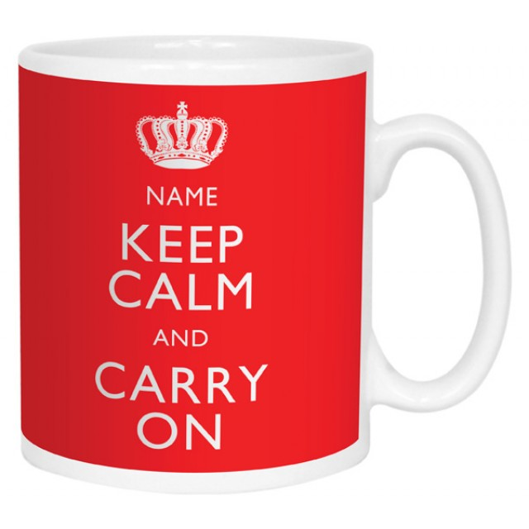
(Fig 39) Printster (NDG) Keep Calm and Carry on Personalised Mug [Online] Available at: https://www.printster.co.uk/keep-calm-and-carry-on-personalised-mug.html [Accessed 10/08/20]
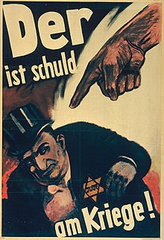
(Fig 40) Hans Schweitzer (1943) He is to Blame for the War! [Online] Available at: https://www.ushmm.org/information/press/press-kits/traveling-exhibitions/state-of-deception/he-is-to-blame-for-the-war [Accessed 20/08/20]
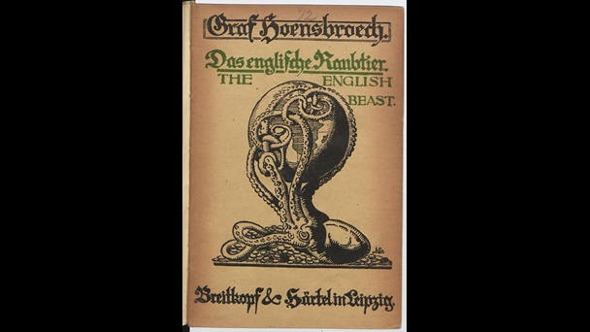
(Fig 42) Count Paul von Hoensbroech [1919] Held by British Library [Online] Available at: https://www.bl.uk/world-war-one/articles/propaganda-as-a-weapon [Accessed 12/12/20]
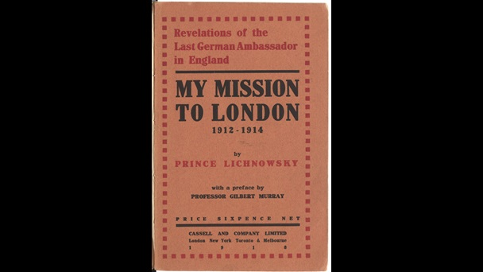
(Fig 41) My Mission to London (1918) Held by British Library [online] Available at: https://www.bl.uk/world-war-one/articles/propaganda-as-a-weapon [Accessed 12/12/20]
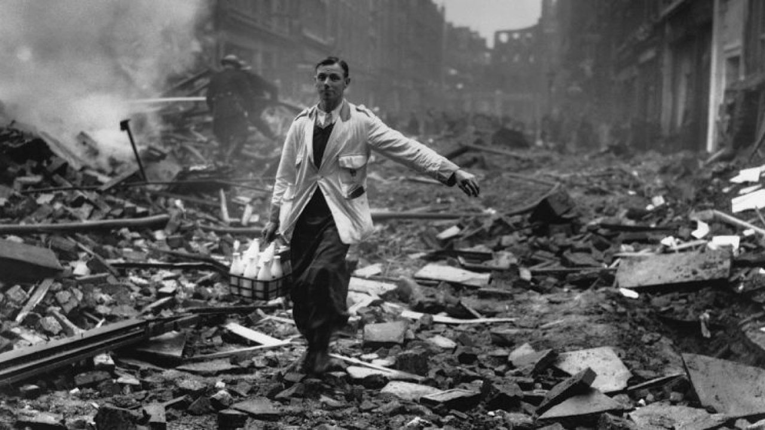
(Fig 42) Fred Morley (NDG) Getty Images [Online] Available at: https://www.warhistoryonline.com/world-war-ii/the-milkman-the-story-behind-blitz.html [Accessed 13/12/20]
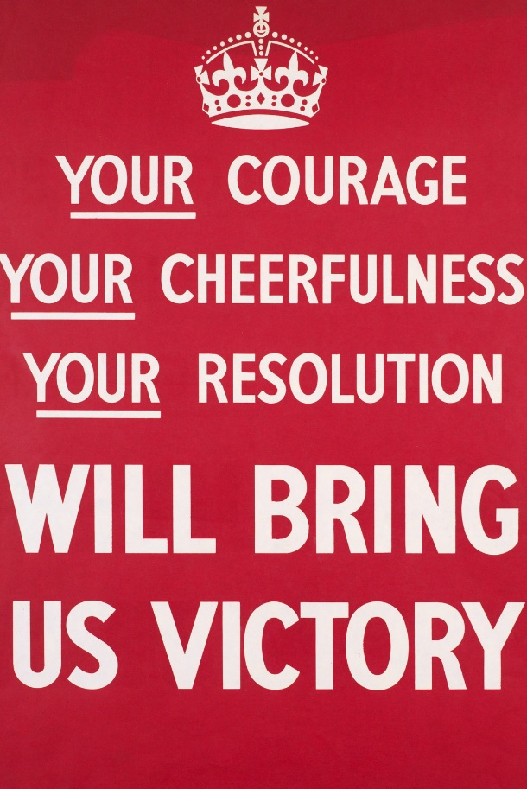
(Fig 43) Economy & Politics (2015) Horrible Histories: Blitzed Brits [Online] Available at: https://wsimag.com/economy-and-politics/16586-horrible-histories-blitzed-brits [Accessed 25/12/20]
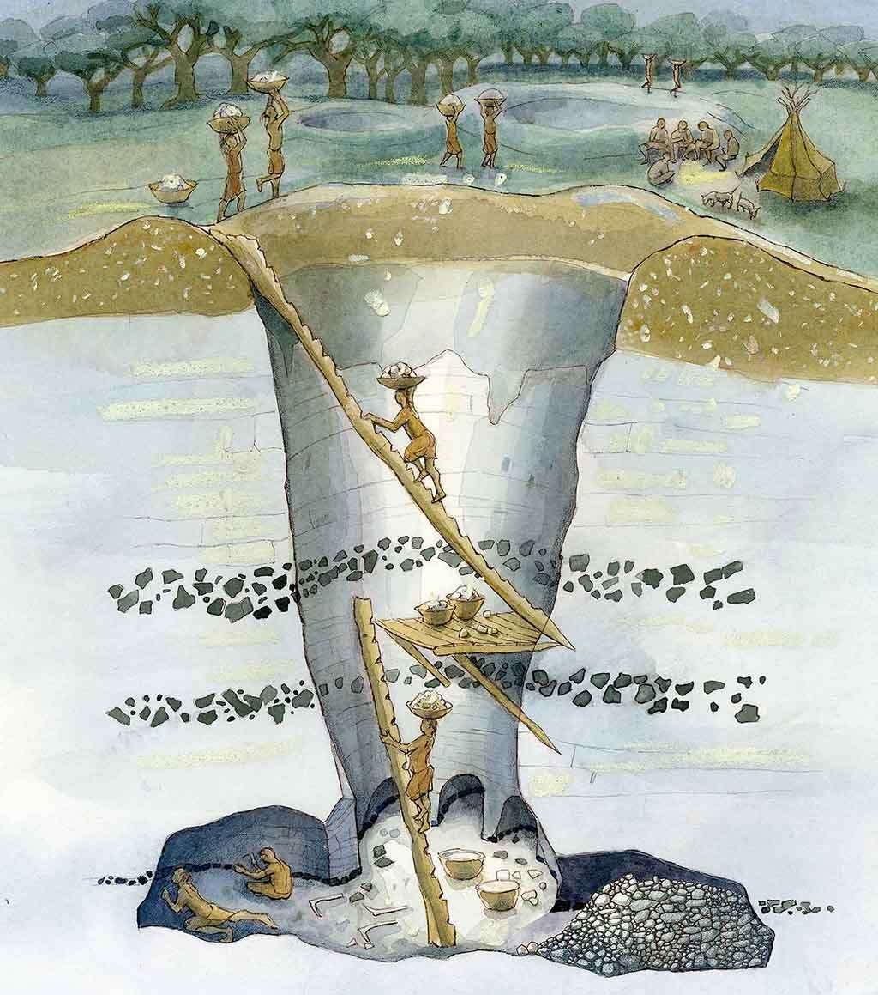
(Fig 32) Grimes Graves Reconstruction (NDG) Illustration by Judith Dobie [Online] Available at: https://www.english-heritage.org.uk/visit/places/grimes-graves-prehistoric-flint-mine/history/ [Accessed 29/12/20]

(Fig 33) Neo-Lithic Axe Head (NDG) Silbury Coins [Online] Available at: https://www.silburycoins.co.uk/product/neolithic-polished-flint-axe-head/ [Accessed 01/01/21]
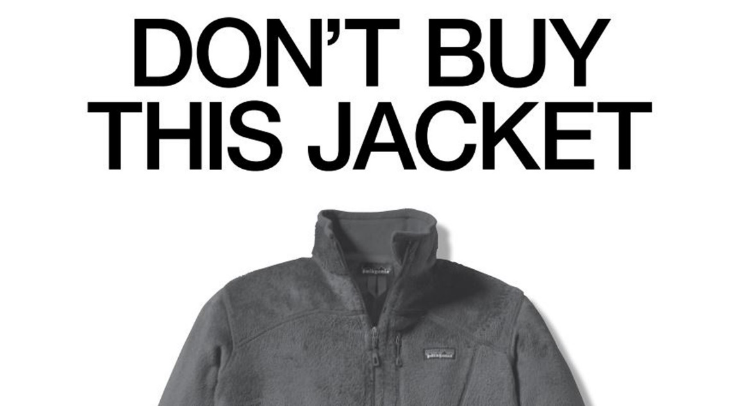
Patagonia (NDG) Don’t Buy This Jacket [Online] Available at: https://www.patagonia.com/stories/dont-buy-this-jacket-black-friday-and-the-new-york-times/story-18615.html [Accessed 06/05/20]
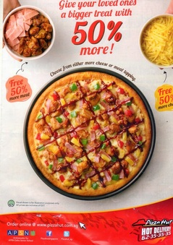
(Fig 12) Card Stacking Propaganda (NDG) Pizza Hut [Online] Available at: http://julienchloefoodpropagandahaha.weebly.com/card-stacking.html# [Accessed 04/05/20]
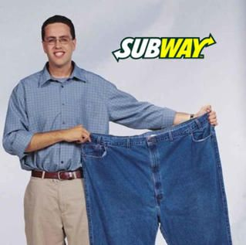
(Fig 13) Plain Folks Propaganda (NDG) Subway [Online] Available at: https://samisperf.weebly.com/plain-folks--testimonial.html# [Accessed 04/05/20]
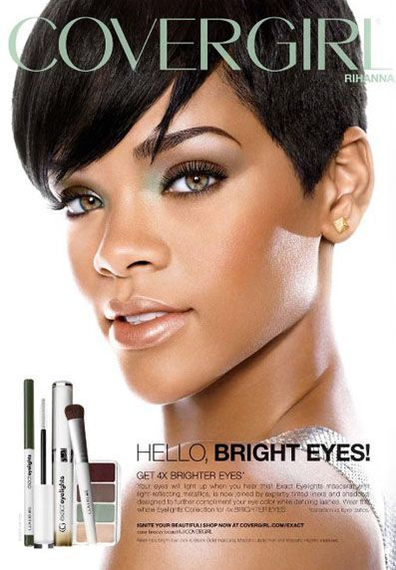
(Fig 14) Testimonial Propaganda (2019) rihannagealbums [Online] Available at: https://rihannaagealbums.blogspot.com/2019/06/rihanna-and-covergirl.html [Accessed 20/06/20]
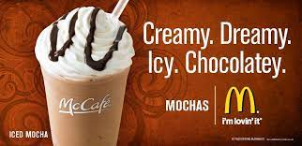
(Fig 15) Glittering Generalities Propaganda (NDG) advergize [Online] Available at: https://www.advergize.com/advertising/examples-of-propaganda/ [Accessed 10/06/20]
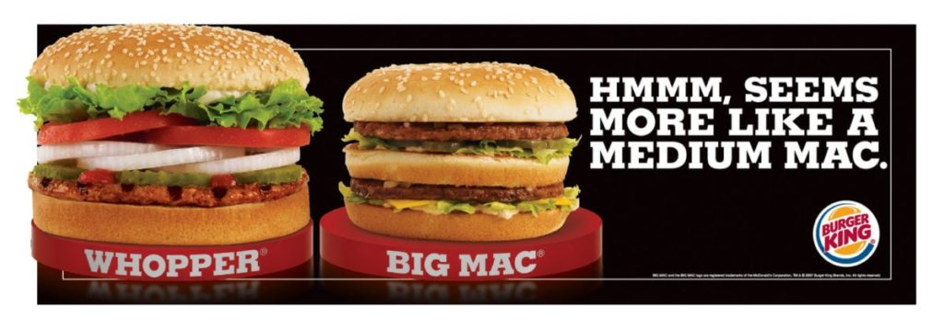
(Fig 16) Name Calling Propaganda (NDG) Burger King [Online] Available at: https://motioncue.com/types-of-propaganda-techniques-in-advertising/#7_Name-calling [Accessed 20/06/20]
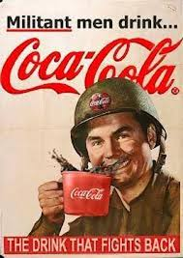
(Fig 17) Transfer Propaganda (NDG) Propaganda on Food Products [Online] Available at: https://propagandafoodcomms9.weebly.com/transfer.html# [Accessed 27/07/20]
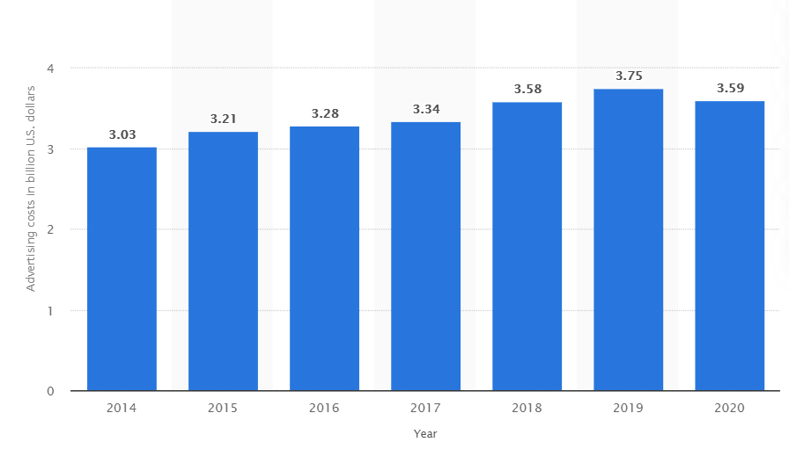
(Fig 27) Nike Spending Budget 2014-2020 [2020] Statista [Online} Available at: https://www.statista.com/statistics/236943/global-advertising-spending/ [Accessed 10/12/20]

Bibliography
Hart, S & Murphy, J (1998) Brands, The New Wealth Creators
Don’t Panic, (2019) What is Brand Purpose? (Online) Available at: https://www.dontpaniclondon.com/what-is-brand-purpose/ (Accessed at 30/12/20)
Bernays, E.L (1928) Propaganda
Bartle, H (2014). Informative Vs Persuasive Advertising, Inner Spark Creative Advertising Agency
Auburn USA [Online] Available at https://www.auburnadvertising.com/articles/98-informative-vs-persuasive-advertising [Accessed 26/11/20]
Business Insider (2020) Coca Cola Advertising Budget [Online] Available at: https://www.businessleader.co.uk/how-much-money-does-coca-cola-spend-on-advertising/80315/#:~:text=Coca%2DCola's%20advertising%20campaigns%20boost,%244bn%20on%20global%20advertising. [Accessed 10/01/21]
Clario (2020) How Many Ads Do You Actually See Daily?! [Online] Available at: https://clario.co/blog/ads-seen-daily/ [Accessed 04/10/20]
Creative Bloq (2018) The Designer’s Guide to Gestalt Theory [Online] Available at: https://www.creativebloq.com/graphic-design/gestalt-theory-10134960 [Accessed: 07/07/20]
D.H. Hepting (2013) A pictures worth [Online] Available at: http://www2.cs.uregina.ca/~hepting/projects/pictures-worth/ [Accessed at: 03/01/21
WarGaming.net (NDG), Radio Propaganda in World War II [Online] Available at: https://wargaming.com/en/news/radio_propaganda/ [Accessed at: 11/11/20]
Nahon-Serfaty, I (2018) The hypodermic effect: How propaganda manipulates our emotions [Online] (April 24 2018) Available at: https://theconversation.com/the-hypodermic-effect-how-propaganda-manipulates-our-emotions-94966 [Accessed: 12/10/20]
‘Deepfake’ Queen’s Speech: Channel 4 criticised for ‘disrespectful’ Christmas message (2020) [Video] Uploaded by The Telegraph
Sky History (2018) How the Nazis Branded Themselves [Online] Available at: https://www.history.co.uk/shows/project-nazi/articles/how-the-nazis-branded-themselves Accessed at: [02/10/20]
Propaganda – All Devices (NDG) Propaganda Techniques and Devices [Online] Available at: https://www.physics.smu.edu/pseudo/Propaganda/alldevices.html Accessed at: [12/01/21]
LJMEDIAWORKS (2016) How can propaganda affect the world in a negative and positive way [Online] Available at: https://ljmediaworks.wordpress.com/2016/01/20/how-can-propaganda-affect-the-world-in-positive-and-negative-way/ Accessed at: [11/05/20]
Govloop (2015) The Difference Between Branding & Propaganda [Online] Available at: https://www.govloop.com/community/blog/difference-branding-propaganda/ Accessed at: [05/06/20]
(Mattingly, Daniel and Yao, Elaine, How Propaganda Manipulates Emotion to Fuel Nationalism: Experimental Evidence from China (January 6, 2020). Available at SSRN: https://ssrn.com/abstract=3514716 or http://dx.doi.org/10.2139/ssrn.3514716) Accessed at: [10/12/20]
Perry, P (2018) The Environmental Costs of Fast Fashion Independent (07 January 2018) Available at: https://www.independent.co.uk/life-style/fashion/environment-costs-fast-fashion-pollution-waste-sustainability-a8139386.html Accessed at: [05/07/20]
War on the Rocks (2020), Pandemic Propaganda and the Global Democracy Crisis [Online] Available at: https://warontherocks.com/2020/05/pandemic-propaganda-and-the-global-democracy-crisis/ Accessed at: [10/12/20]
The World Bank (2019) How Much Do Our Wardrobes Cost to The Environment? [Online] Available at: https://www.worldbank.org/en/news/feature/2019/09/23/costo-moda-medio-ambiente [Accessed 20/04/20]
Cambridge Dictionary (NDG) (Online) Available at: https://dictionary.cambridge.org/dictionary/english/on-a-need-to-know-basis [Accessed 13/01/21]
Fast Company (2019) Fyre Festivals lead designer talk abouts branding a scam [Online] Available at: https://www.fastcompany.com/90324689/fyre-festivals-lead-designer-on-branding-a-scam [Accessed 12/12/20]
CNBC Make It (2019) Fyre Festival: How a 25-year-old scammed investors out of $26 million Available at: https://www.cnbc.com/2019/08/18/how-fyre-festivals-organizer-scammed-investors-out-of-26-million.html [Accessed 25/12/20]
BBC News (2019) Fyre Festival: Inside the world’s biggest flop [Online] Available at: https://www.bbc.co.uk/news/newsbeat-46904445 [Accessed 09/11/20]
Shwab, K (2019) Fyre Festival lead designer talks about branding a scam (March 31, 2019) Available at: https://www.brandknewmag.com/fyre-festivals-lead-designer-talks-about-branding-a-scam/ [Accessed 09/11/20]
English Heritage (NDG) Significance of Grimes Graves [Online] Available at: https://www.english-heritage.org.uk/visit/places/grimes-graves-prehistoric-flint-mine/history/significance/ [Accessed 12/01/21]
Megalitihc (2017) Grime’s Graves Flint Mines’ [Online] Available at: https://www.megalithic.co.uk/article.php?sid=4800 [Accessed 10/01/21]
Theather, AM (2008) Mining and Materiality in the British Neolithic, Department of Archaeology and Prehistory, University of Sheffield, UK [Online] Available at: https://core.ac.uk/download/pdf/42604504.pdf [Accessed 09/01/21]
Barthes, R (1991) Mythologies
How Great Leaders Inspire Action (2009) [Video] Presented by Simon Sinek TedxPuget Sound
Winson, R (2014) Sorry Beyoncé, Rosie the Riveter is no feminist icon. Here’s why The Guardian [Online] [23 July 2014] Available at: https://www.theguardian.com/commentisfree/2014/jul/23/beyonce-rosie-the-riveter-feminist-icon [Accessed 12/12/20]
Scott, E (2014) Beyoncé dresses up as feminist icon Rosie the Riveter, looks ***Flawless Cosmopolitan [Online] [July 22 2014] Available at: https://www.cosmopolitan.com/uk/entertainment/news/a28129/beyonce-rosie-the-riveter-feminist/ [Accessed 01/12/20]
British Library (2014) Propaganda as a weapon? Influencing International opinion [Online] Available at: https://www.bl.uk/world-war-one/articles/propaganda-as-a-weapon# [Accessed 01/11/20]
Bell, P (2014) The Kerfuffle Over Beyonce Posing as Rosie the Riveter Shows We Need to Stop This Feminist Infighting HuffingtonPost [Online] [24 August 2014] Available at: https://www.huffingtonpost.co.uk/poorna-bell/beyonce-rosie-the-riveter_b_5617268.html?guccounter=1&guce_referrer=aHR0cHM6Ly93d3cuZ29vZ2xlLmNvLnVrLw&guce_referrer_sig=AQAAAMs51tECfiCotQdQmoDap96Au30XsBS_L1oz6qxO_aAup-0YAtJEuQzxuRGbnVl-rkSgm1dPLAlZDiGaf6RdYp7VRFtLqEOv2lXflc2sa6nWcdHe0d4VZSgJiydpq6NuhxA6IfRiBsDqBposzteNEpOHXoOVGuZFyfiTGxslVr5T [Accessed 31/12/20]
Overy, R (2020) Why the cruel myth of ‘Blitz Spirit’ is no model for how to fight coronavirus The Guardian [Online] [19 March 2020] Available at: https://www.theguardian.com/commentisfree/2020/mar/19/myth-blitz-spirit-model-coronavirus# [Accessed 25/12/20]
Hartherly, O (2016) Keep Calm and Carry On – the sinister message behind the slogan that seduced the nation The Guardian [Online] [8 January 2016] Available at: https://www.theguardian.com/books/2016/jan/08/keep-calm-and-carry-on-posters-austerity-ubiquity-sinister-implications [Accessed 22/12/20]
Historic UK (NDG) The Blitz Spirit [Online] Available at: https://www.historic-uk.com/HistoryUK/HistoryofBritain/Blitz-Spirit/ [Accessed 10/12/20]
USA Today (NDG) 5 Memorable World Cup Chants [Online] Available at: https://eu.usatoday.com/story/sports/soccer/2014/07/01/5-memorable-world-cup-chants/11833297/ [Accessed 01/01/21]
DiResta, R (2020) The Supply of Disinformation Will Soon be Infinite The Atlantic [Online] [September 20 2020] Available at: https://www.theatlantic.com/ideas/archive/2020/09/future-propaganda-will-be-computer-generated/616400/ [Accessed 20/12/20]
Investopedia (2020) Moore’s Law [Online] Available at: https://www.investopedia.com/terms/m/mooreslaw.asp#:~:text=Moore's%20Law%20refers%20to%20Moore's,will%20pay%20less%20for%20them [Accessed 28/12/20]
Lafrance, A (2020) A Computer Tried (and failed) to Write This Article The Atlantic [Online] [June 8 2016] Available at: https://www.theatlantic.com/technology/archive/2016/06/story-by-a-human/485984/ [Accessed 22/12/20]

